# Design report

## Purpose

The purpose of this document is to provide a rationale for the design choices made for the website requested by AllStyle Homes to be created by Online System Solutions.

## Design metaphor

## A hybrid design metaphor would be best suited to the website requested by AllStyle Homes because the website uses components from both the organisational metaphor (About, FAQ, Testimonials) and functional metaphor (Designs, Our Process, Contact), another reason why a hybrid design metaphor is most suitable is because it is more versatile and flexible compared to organisational and functional metaphors.

## Navigation map

The following diagram shows a detailed navigation map of the website

## 

## Content map

The content map shows the mapping of content chunks to web pages. The content map is provided below.

|  |  |  |  |  |  |  |  |  |
| --- | --- | --- | --- | --- | --- | --- | --- | --- |
|  | ABOUT | CONTACT | DESIGNS | FAQ | HOME | OUR PROCESS | PRIVACY | TESTIMONIALS |
| Unique ID | 01 | 02 | 03 | 04 | 05 | 06 | 07 | 08 |
| Description | General info on company | Contact info.  Phone, email, map. | Display homes built by AllStyle Homes | FAQ from customers | Introduction to AllStyle Homes | Construction process from AllStyle Homes | Privacy statement | Customer statements about AllStyle Homes |
| Original Source Format | HTML5 | HTML5 | JPG/ HTML5 | HTML5 | HTML5 | HTML5 | PDF | HTML5 |
| Expected format Changes | None | None | None | None | None | None | None | None |
| Update Frequency | As required | As required | Monthly | Monthly | As required | As required | As required | Monthly |
| Information Owner | Alex/Sheree Knox | Alex/Sheree Knox | Alex/Sheree Knox | Customers | Alex/Sheree Knox | Alex/Sheree Knox | Alex/Sheree Knox | Customers |

Intended audience for all pages are people looking for a new home or an investment property.

There is a hyperlink on all pages to a government loan calculator on an image of a loan calculator.

|  |  |  |  |  |
| --- | --- | --- | --- | --- |
|  | LOGIN | APPLIANCES | FIT OUTS | ADDITIONAL |
| Unique ID | 09 | 10 | 11 | 12 |
| Description | Login page for staff/customers | Page of available appliances | Page of fit outs for home | Additional features for home |
| Original Source Format | HTML5 | JPG/ HTML5 | JPG/ HTML5 | JPG/ HTML5 |
| Expected format Changes | None | None | None | None |
| Update Frequency | As required | As required | As required | As required |
| Information Owner | Alex/Sheree Knox | Alex/Sheree Knox | Alex/Sheree Knox | Customers |

## Labelling

The labels intended to be used on the website are as follows;

* About
* Contact
* Designs
* Frequently Asked Questions (FAQ)
* Home
* Our Process
* Privacy
* Testimonials

## Menu systems

The menu system that has been selected for AllStyle Homes is a hyperlink menu system. This is because a hyperlink menu system is the easiest to use with the linear navigation system, it is also the easiest to create and is the most likely menu system that can be accessed by everyone.

## Accessibility and usability

Accessibility

According to the Seven Principles of Universal Design, websites should be created with people who have limited motor functions in mind, meaning that people who have limited use of a mouse should be able to navigate a site with the use of a keyboard, ensure that people who are visually impaired can use a reader to access content on the site and use alt tags for images (Principle One: Equitable Use). Principle Two: Flexibility in Use states that nothing in the site should be set at a predetermined speed so that the user can go at his/her own pace. Principle Three: Simple and Intuitive states that the website should be clear and concise and the design of the site should be easy to understand and be consistent throughout the entire site. Principle Four: Perceptible Information states that information is to be presented effectively regardless of the user’s sensory abilities or ambient conditions. Principle Five: Tolerance for Error states that the design of the site should minimise hazards and the adverse effects of accidental or unintentional actions. Principle Six: Low Physical Effort states that the design of the site should be used efficiently, comfortably and with a minimum of fatigue, meaning that there can be keyboard shortcuts to complete actions (Ctrl +C for copying, Ctrl + V for paste and Ctrl + P to pause a video). Finally Principle Seven: Size and Space for Approach and Use states that the appropriate size and space is provided for users, regardless of their position, body size, posture or mobility. Other things to include with accessibility is to not have an overcrowded page and to not use navigation systems such as cascading fly-out menus or other things that require precise movements with the mouse.

For more information about the Seven Principles of Universal Design check out

<http://projectone.cannect.org/universal-design/seven-principles.php>

Usability

Usability is a very important aspect for building a website because it defines how easy a website is to navigate, read etc. If a website has too much information on a page, it will be much more difficult to read. Especially if there aren’t any breaks in the paragraphs (images etc.). Having a font size that is too small may cause a user to have a look at a similar website instead of yours if it isn’t very user friendly. To make a website usable, it should be easy to read and navigate through the site, not have too many colours, have a consistent colour and design scheme and have a text font that is not too small as well as a font style that isn’t difficult to read.

## Appendix

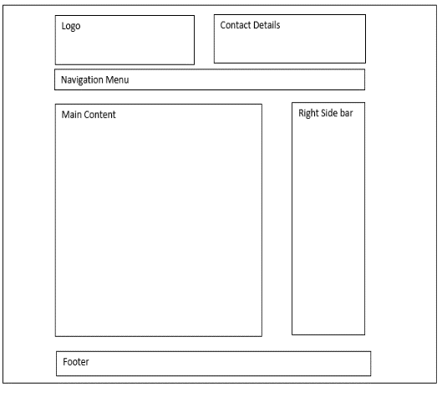Mock-up 1

This is the mock-up design that has been chosen for the website because it is the most simple, yet effective design for where information and other items are placed in the website.

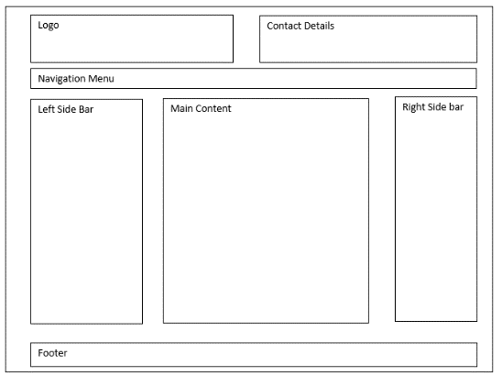

Mock-up 2

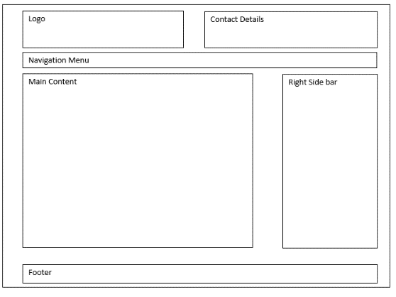Mock-up 3